Ct331 Assignment 2

Gary Kelly

14493172

<https://github.com/GaryK95/ct331_assignment2>

Question 1

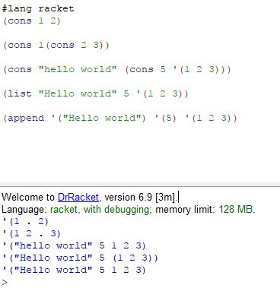

Q1)-B,

Cons builds pairs not lists, the dot separates the elements in the pair

List creates a list

Append joins all the elements of the lists into one big long list

Question 2

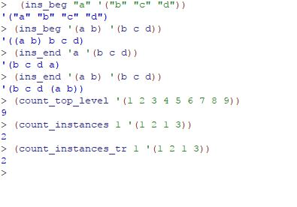

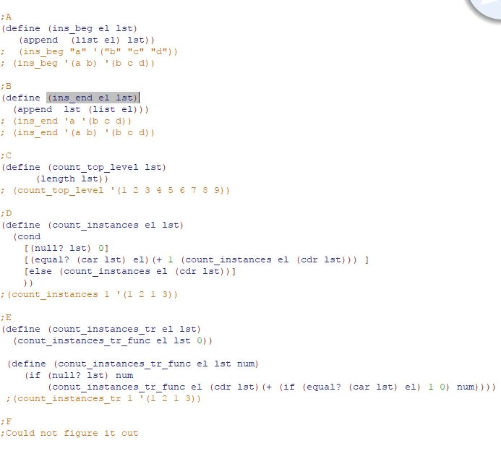

Question 3

Could not do, sorry